The History of the Harp

Name ______________________________ Date ____________________________

Complete the timeline below by listing the types of harps or places of origin. Then list several facts about each type of harp below. Use the following Website to find information. <http://eu.harp.com/history-of-the-harp.htm>

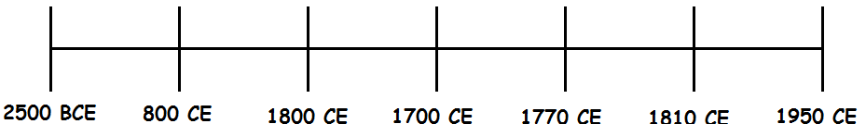

Ancient Egypt - _______________________________________________________

___________________________________________________________________

Irish Harps - _________________________________________________________

___________________________________________________________________

Diatonic Harps - _______________________________________________________

___________________________________________________________________

Triple Strung Harps - ___________________________________________________

___________________________________________________________________

___________________________________________________________________

Single Action Pedal Harps - _______________________________________________

___________________________________________________________________

___________________________________________________________________

Chromatic / Cross Strung Harp - __________________________________________

___________________________________________________________________

___________________________________________________________________

Double-Action pedal Harps - ______________________________________________

___________________________________________________________________

___________________________________________________________________

After you have listed facts about the harps above, choose a partner from the class and visit the following Website: <http://www.playharp.com/play-harp-here/>. You and your partner practice playing several of the songs. Twinkle Twinkle Little Star is probably the easiest. So you might want to start with that song. The class can have a contest to see who the best virtual harpist is.

